深 圳 大 学 实 验 报 告

课程名称： 数据库系统

实验项目名称： Basic SQL command LAB

学院： Computer Science and Software Engineering

专业： Computer Science and Technology

指导教师： Basker George

报告人_沈晨玙__学号：2019092121__班级：_19计科国际班_

实验时间： 07th October 2020

实验报告提交时间： 07th October 2020

教务部制
实验目的与要求：(Purpose of Experiment purpose and Requirements)
* Please show all work for these problems.
Just writing down the answer will not get full credit.

Basic SQL command LAB

Note: create a Table EMP_your_StudentID and DEPT_your_studentID with all required constraints both Integrity and Referential Integrity Constraint.

EMP Table:
EMPNO | PRIMARY KEY NOT NULL  IF PRIMARY KEY MODIFED THEN CHILD MUST BE UPDATED | NUMBER(4)
ENAME | NOT NULL | VARCHAR2(10)
JOB | NOT NULL | VARCHAR2(9)
MGR | REFERENCES EMP(EMPNO) | NUMBER(4)
HIREDATE | NOT NULL  CANNOT BE GREATER THAN TODAYS DATE | DATE
SAL | NOT NULL  AND MORE THAN 5000 | NUMBER(7,2)
COMM |  | NUMBER(7,2)
DEPTNO | REFERENCES DEPT TABLE  DEFAULT 10 | NUMBER(2)

DEPT TABLE:

DEPTNO | PRIMARY KEY NOT NULL  DON’T ALLOW PRIMARY KEY TO BE MODIFIED IF CHILD RECORD EXIST | NUMBER(2)
DNAME |  | CHAR(10)
LOC |  | CHAR(10)

INSERT TUPLES FOR EMP TABLE:

EMPNO | ENAME | JOB | MGR | HIREDATE | SAL | COMM | DEPTNO
7369 | SMITH | CLERK | 7902 | 17-DEC-90 | 13750 | NULL | 20
7499 | ALLEN | SALESMAN | 7698 | 20-FEB-89 | 19000 | 6400 | 30
7521 | WARD | SALESMAN | 7698 | 22-FEB-93 | 18500 | 4250 | 30
7566 | JONES | MANAGER | 7839 | 02-APR-89 | 26850 |  | 20
7654 | MARTIN | SALESMAN | 7698 | 28-SEP-97 | 15675 | 3500 | 30
7698 | BLAKE | MANAGER | 7839 | 01-MAY-90 | 24000 |  | 30
7782 | CLARK | MANAGER | 7839 | 09-JUN-88 | 27500 |  | 10
7788 | SCOTT | ANALYST | 7566 | 19-APR-87 | 19500 |  | 20
7839 | KING | PRESIDENT |  | 17-NOV-83 | 82500 |  | 10
7844 | TURNER | SALESMAN | 7698 | 08-SEP-92 | 18500 | 6250 | 30
7876 | ADAMS | CLERK | 7788 | 23-MAY-96 | 11900 |  | 20
7900 | JAMES | CLERK | 7698 | 03-DEC-95 | 12500 |  | 30
7902 | FORD | ANALYST | 7566 | 03-DEC-91 | 21500 |  | 20
7934 | MILLER | CLERK | 7782 | 23-JAN-95 | 13250 |  | 10
EMPNO | ENAME | JOB | MGR | HIREDATE | SAL | COMM | DEPTNO
3258 | GREEN | SALESMAN | 4422 | 24-JUL-95 | 18500 | 2750 | 50
4422 | STEVENS | MANAGER | 7839 | 14-JAN-94 | 24750 |  | 50
6548 | BARNES | CLERK | 4422 | 16-JAN-95 | 11950 |  | 50
7500 | CAMPBELL | ANALYST | 7566 | 30-OCT-92 | 24500 | 0 | 40

INSERT TUPLES FOR DEPT TABLE:

DEPTNO | DNAME | LOC
10 | ACCOUNTING | LONDON
30 | SALES | LIVERPOOL
40 | OPERATIONS | STAFFORD
50 | MARKETING | LUTON
20 | RESEARCH | PRESTON

- List all information about the employees.

2 List all information about the departments

3 List only the following information from the EMP table ( Employee name, employee number, salary, department number)

4 List details of employees in departments 10 and 30.

5 List all the jobs in the EMP table eliminating duplicates.

6. What are the names of the employees who earn less than £20,000?

7. What is the name, job title and employee number of the person in department 20 who earns more than £25000?

8. Find all employees whose job is either Clerk or Salesman.

9. Find any Clerk who is not in department 10.

10. Find everyone whose job is Salesman and all the Analysts in department 20.

11. Find all the employees who earn between £15,000 and £20,000.
Show the employee name, department and salary.

12 Find the name of the President.

13 Find all the employees whose last names end with S

14 List the employees whose names have TH or LL in them

15 List only those employees who receive commission.

16 Find the name, job, salary, hiredate, and department number of all employees by alphabetical order of name.

17. Find the name, job, salary, hiredate and department number of all employees in ascending order by their salaries.

18. List all salesmen in descending order by commission divided by their salary.

19. Order employees in department 30 who receive commision, in ascending order by commission

20 Find the names, jobs, salaries and commissions of all employees who do not have managers.

- Find all the salesmen in department 30 who have a salary greater than or equal to £18000.
- Find the employees who were hired before 01-Jan-1998 and have salary above 5000 or below 1000.
- What is the command to add primary key constraint to EMPNO
- What is the command to add a new column EMP_family_name to existing EMP table
- How to drop primary key constraint for EMPNO
- rename EMP table to EMPLOYEE
- rename EMPLOYEE back to EMP
- What is the SQL command to remove column EMP_family_name from EMP table
- What is the SQL command to copy emp table to employee table
- What is the SQL command to drop employee table
- What is the SQL command to display name’s of employee entered interactively from user
- What is the SQL command to find the employee whose commission is NULL

实验过程及内容：(Methods and steps)

0 Create a database
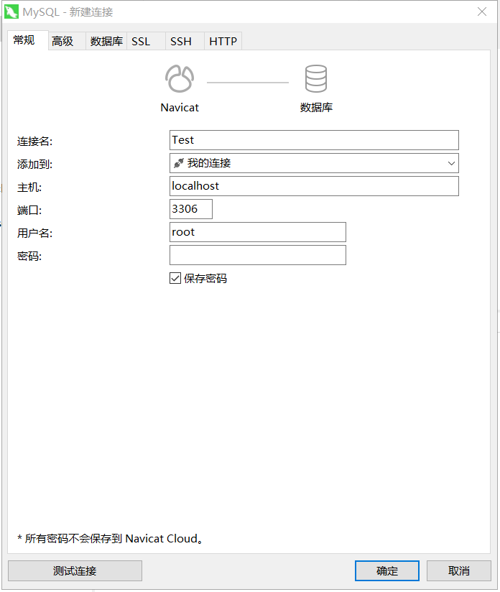
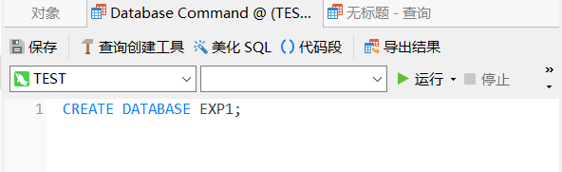
Create two tables
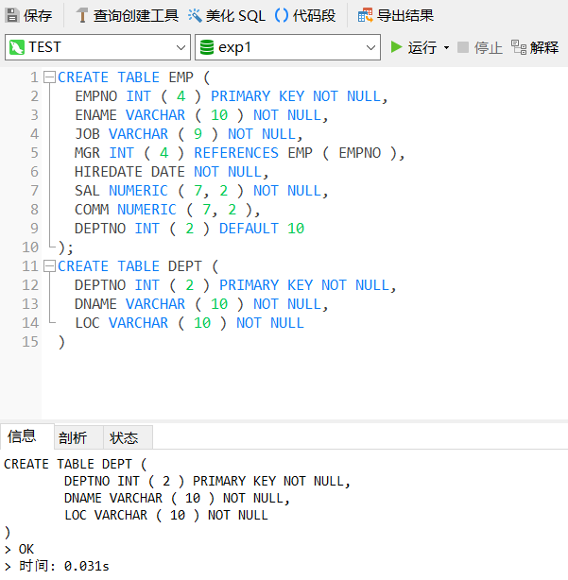

Insert data
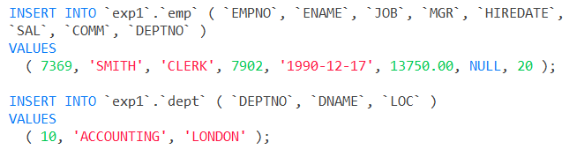
1 List all information about the employees.
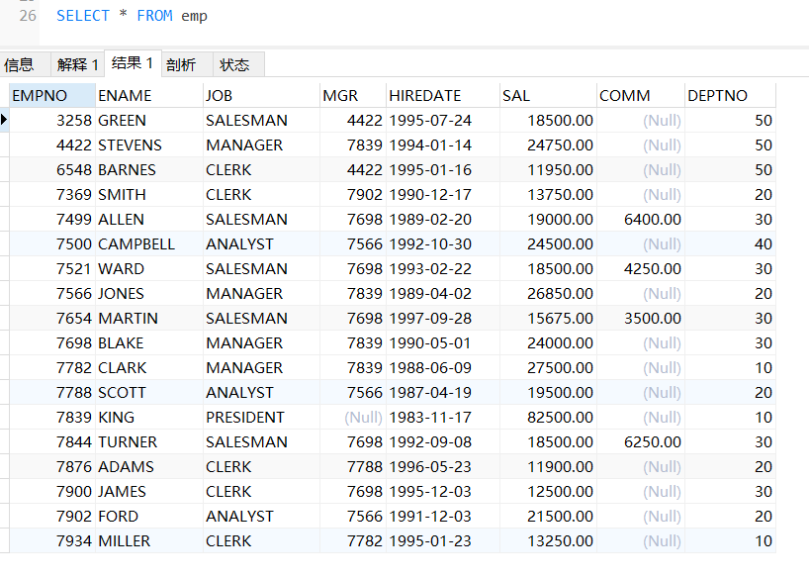
2 List all information about the departments
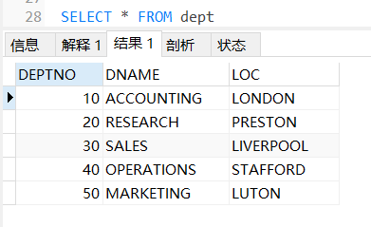
- List only the following information from the EMP table ( Employee name, employee number, salary, department number)
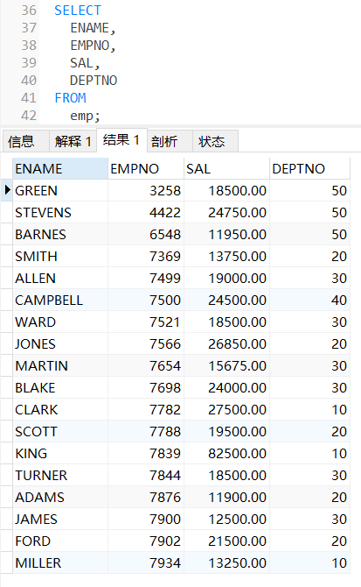
4 List details of employees in departments 10 and 30.
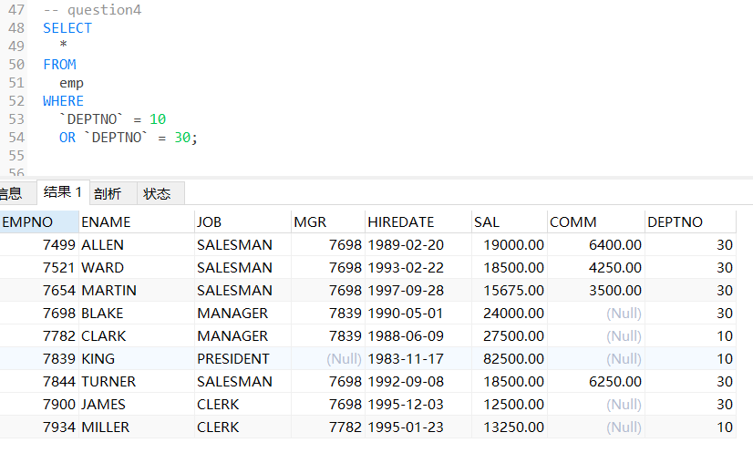
5 List all the jobs in the EMP table eliminating duplicates.
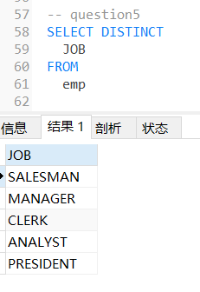
6. What are the names of the employees who earn less than £20,000?
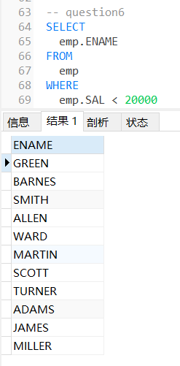

7. What is the name, job title and employee number of the person in department 20 who earns more than £25000?
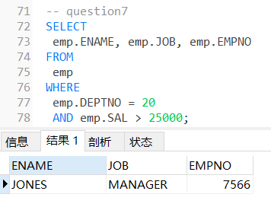
8. Find all employees whose job is either Clerk or Salesman.
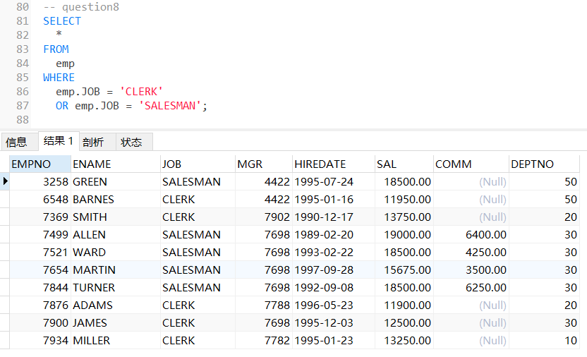
- Find any Clerk who is not in department 10.
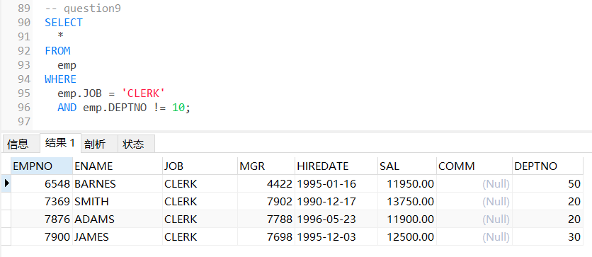

- Find everyone whose job is Salesman and all the Analysts in department 20.
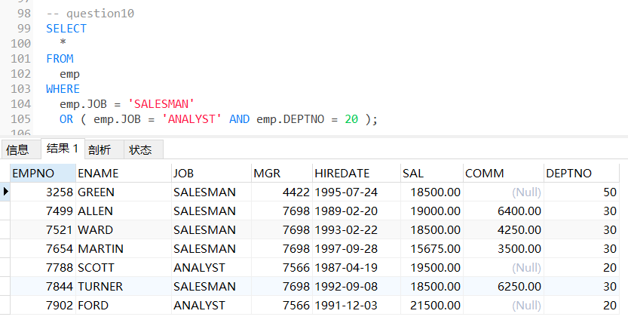
11. Find all the employees who earn between £15,000 and £20,000.
Show the employee name, department and salary.
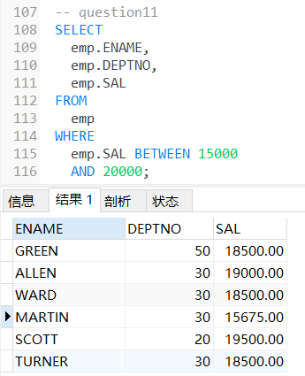
12 Find the name of the President.
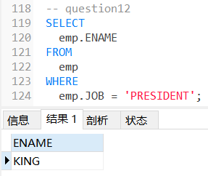
13 Find all the employees whose last names end with S
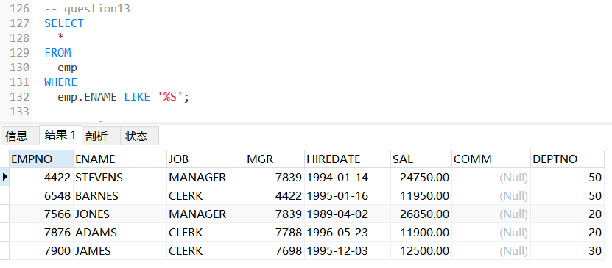
14 List the employees whose names have TH or LL in them
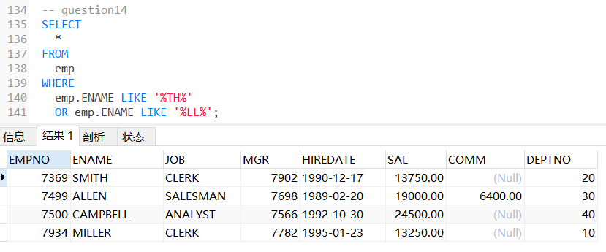

15 List only those employees who receive commission.
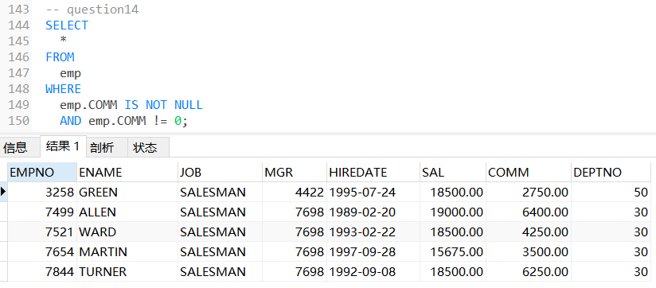
16 Find the name, job, salary, hiredate, and department number of all employees by alphabetical order of name.
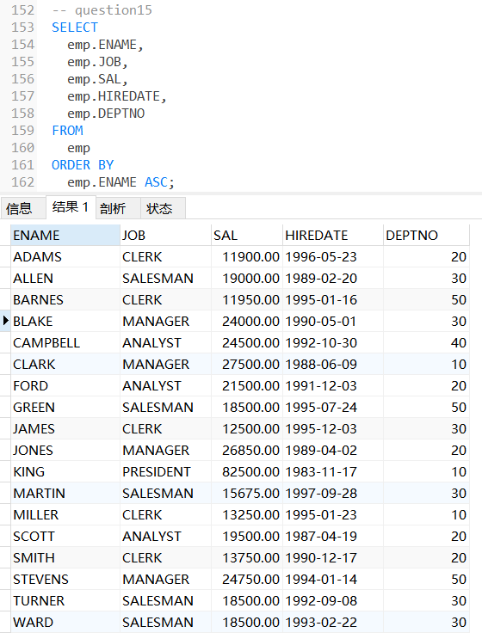

17. Find the name, job, salary, hiredate and department number of all employees in ascending order by their salaries.
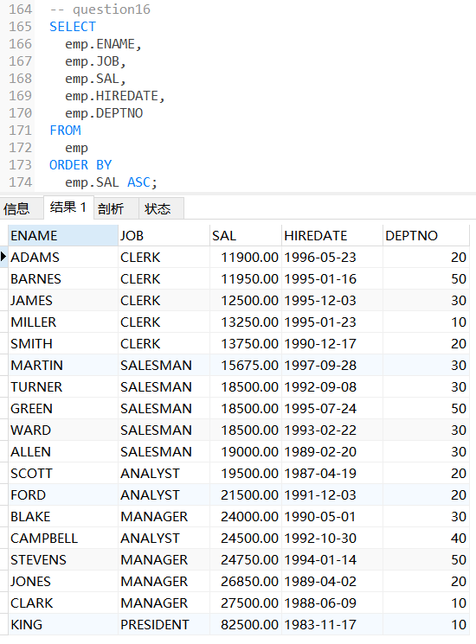
18. List all salesmen in descending order by commission divided by their salary.
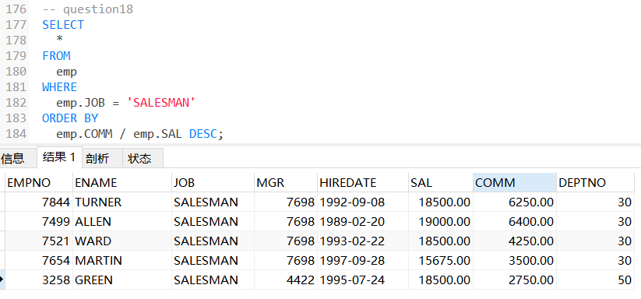
19. Order employees in department 30 who receive commision, in ascending order by commission
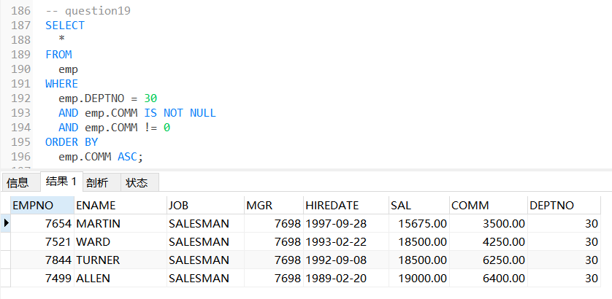
- Find the names, jobs, salaries and commissions of all employees who do not have managers.
Method1:
Step1：find out all the mangers’ EMPNO
Step2：check whether the MGR is in the selected table
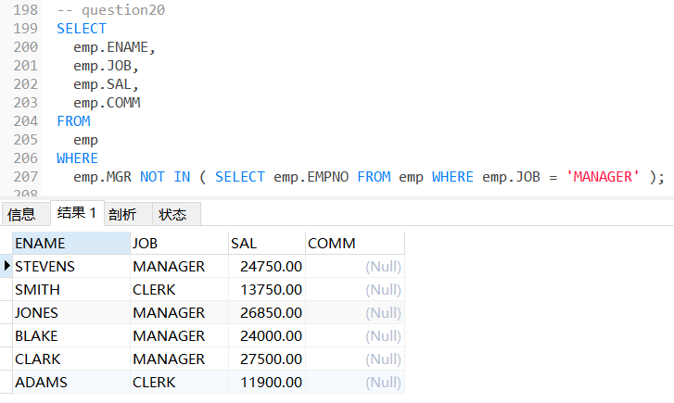
Method2:
Step1：self-joins
Step2：check whether while e2.JOB isn’t 'MANAGER' and e1.MGR equals to e2.EMPNO.
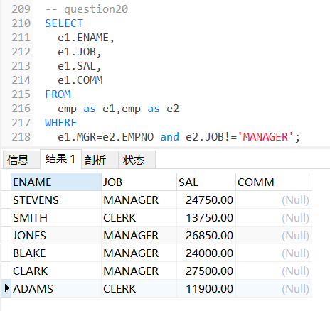
21 Find all the salesmen in department 30 who have a salary greater than or equal to £18000.
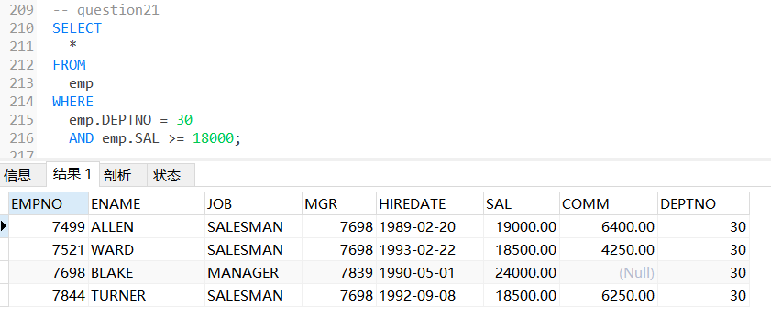

22 Find the employees who were hired before 01-Jan-1998 and have salary above 5000 or below 1000.
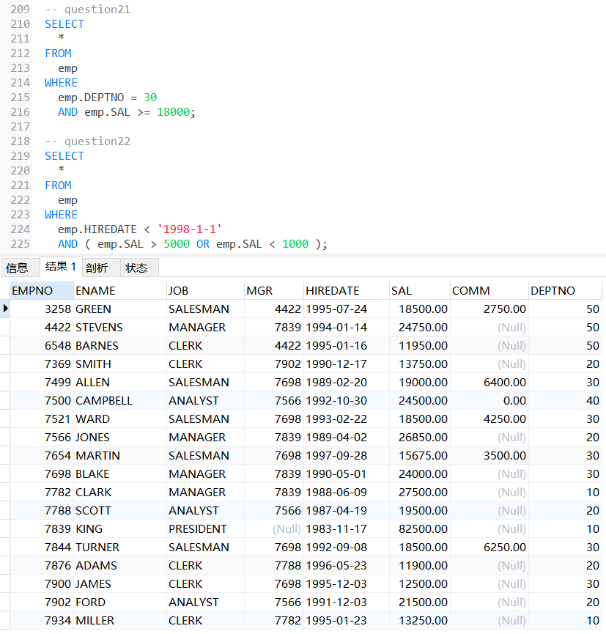
23 What is the command to add primary key constraint to EMPNO
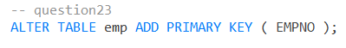
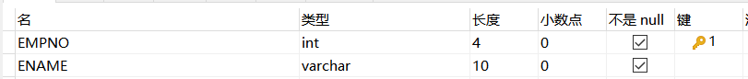
24 What is the command to add a new column EMP_family_name to existing EMP table
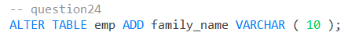
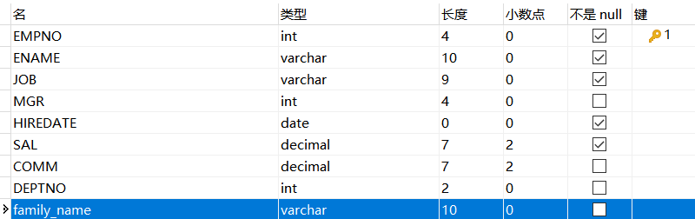
25 How to drop primary key constraint for EMPNO
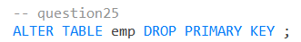
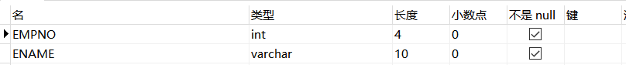
26 rename EMP table to EMPLOYEE
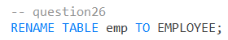
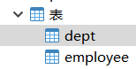
27 rename EMPLOYEE back to EMP
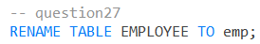
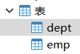
28 What is the SQL command to remove column EMP_family_name from EMP table
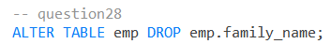
29 What is the SQL command to copy emp table to employee table
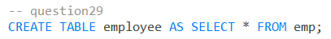
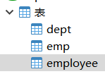
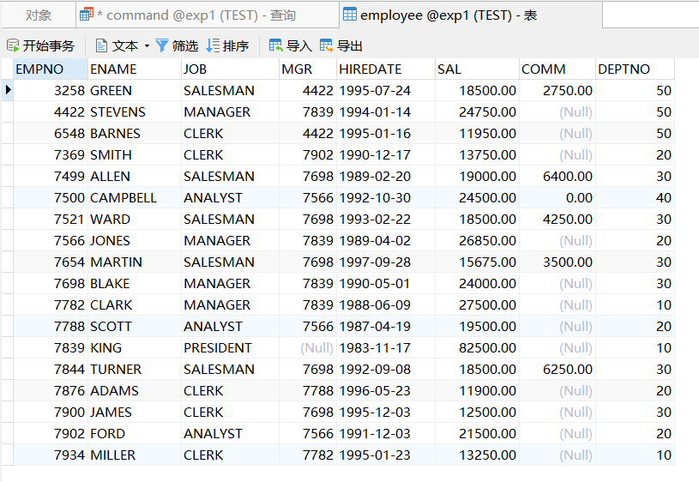
30 What is the SQL command to drop employee table
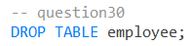

31 What is the SQL command to display name’s of employee entered interactively from user
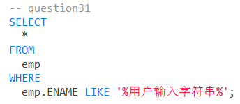
32 What is the SQL command to find the employee whose commission is NULL
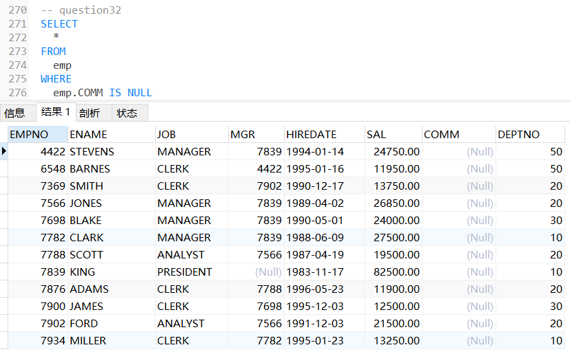
数据处理分析：(Experiment process and content)
本次实验主要涉及了SQL的基本查询，修改，撤销等功能。
本次实验的环境是基于MySQL与Navicat。
实验主要运用以下几种语法格式
①查询操作
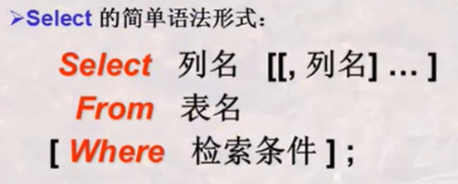
注：1. Select是利用关系元组的投影选择出若干属性列组成新的关系元组。
(Select Distinct可以消除重复元素。)
- From后若接n个元组是以笛卡尔积组成新的关系元组。
- Where后可接比较运算，范围查询，集合查询，空值查询，字符串匹配查询，逻辑查询。

②插入操作
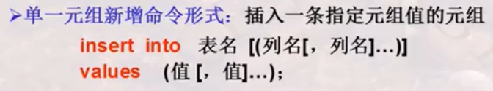
③删除操作

④表格修改操作

④数据库修改操作
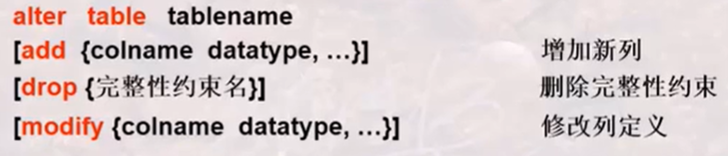
更加具体的操作可以查询帮助表https://www.runoob.com/sql/sql-tutorial.html

深圳大学学生实验报告用纸

指导教师批阅意见：

成绩评定：

指导教师签字：Basker George
2019年09月25日
备注：
注：1、报告内的项目或内容设置，可根据实际情况加以调整和补充。
2、教师批改学生实验报告时间应在学生提交实验报告时间后10日内。

